CBSNews

50 Years Later, Kitty Genovese Murder Case Still Grips NYC, Nation
March 11, 2014 2:49 PM
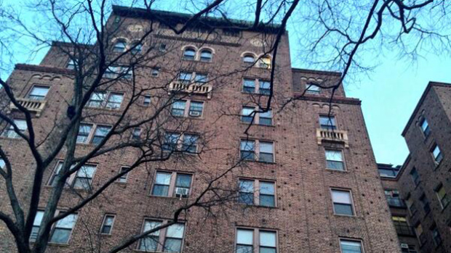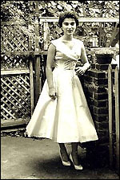

NEW YORK (CBSNewYork/AP) — Kitty Genovese’s screams for help couldn’t save her on the night she was murdered outside her apartment building in 1964. Fifty years later, those screams still echo, a symbol of urban breakdown and city dwellers’ seeming callousness toward their neighbors.
The case “caught the spirit of the time,” said Thomas Reppetto, a police historian. “It seemed to symbolize that society no longer cared about other people.”
Genovese’s random stabbing by Winston Moseley on March 13, 1964, in Kew Gardens, Queens, became a sensation when The New York Times reported that “38 respectable, law-abiding citizens” in Queens watched the attack over more than half an hour and didn’t call police until it was too late.
While the number of people who saw or heard the crime has since become a matter of dispute, Genovese’s murder left its mark on public policy and psychology.
It has been credited with spurring adoption of the 911 system in 1968 as well as “Good Samaritan” laws that give legal protection to people who help those in trouble.
The case also gave rise to research into the “bystander effect” — the phenomenon in which a group of onlookers fails to help someone in distress — and is often featured in psychology textbooks.
At least five books about Genovese’s killing have come out recently or will be published this year, a testament to the enduring fascination with the case.
“Many people were murdered that year, over 600, but she haunts us because she could have been helped and nobody did,” said Peter Hellman, a journalist and author of the e-book “Fifty Years After Kitty Genovese, Inside the Case That Rocked Our Faith in Each Other.”
According to police reports and trial testimony, Genovese was a 28-year-old bar manager living in a seemingly safe, well-kept Queens neighborhood when she was attacked while returning home from work after 3 a.m.
Moseley later told police he had been driving around looking for a woman to kill. He spotted Genovese, chased her and stabbed her in the back. Genovese screamed, and a neighbor yelled from his window, “Leave that girl alone!”
Moseley retreated to his car but returned minutes later and found Genovese in a hallway at the back of her building, where she had collapsed. He stabbed her several more times and raped her as she lay dying.
The story was not widely reported until A.M. Rosenthal, then metro editor of the Times, had lunch with Police Commissioner Michael Murphy, who told him about the 38 witnesses. Rosenthal assigned a reporter to write a story about the neighbors’ apathy.
“I didn’t want to get involved,” one neighbor was quoted as saying.
The story seemed to show that New York was an urban hell where no one would lift a finger to help a neighbor.
“It fit some people’s anti-New York perspective,” said Philip Zimbardo, a retired professor of psychology at Stanford University.
Some later accounts of Genovese’s murder challenged the Times’ version.
Kevin Cook, author of “Kitty Genovese: The Murder, the Bystanders, the Crime That Changed America,” argues that only a few neighbors saw enough of the attack to understand much of what was going on, and some of them did try to help.
The Times revisited the case in 2004 on the 40th anniversary. A former prosecutor told the paper then that while far fewer than 38 saw the murder, many others heard the screams.
Catherine Pelonero argues in her book “Kitty Genovese: A True Account of a Public Murder and its Private Consequences” that the reporting from 1964 was fundamentally correct: “Many people heard the screams and had very good reasonable cause to believe that a crime was taking place.”
“The most chilling part is that once she reached the back of the building, she was lying down there for several minutes calling for help,” Pelonero added. “She was saying, ‘It’s Kitty! I’m stabbed! Help me!'”
Moseley was convicted of murder and sentenced to death, a punishment later reduced to life in prison.
He escaped during a transfer to a hospital in Buffalo in 1968, took five people hostage and raped a woman in front of her husband before surrendering to police. Now 79, Moseley is one of the longest-serving inmates in the New York state prison system.
In reaction to the case, Fordham University Professor Harold Takooshian began studying bystander behavior as a graduate student in 1978. Working under the social psychologist Stanley Milgram, Takooshian conducted experiments that involved pretending to commit crimes to observe bystanders’ reaction.
“The field emerged entirely because of her, and now it’s a very large field,” Takooshian said.
Genovese emerges in the new books as a compelling figure in her own right, a high-spirited young woman known as the class cut-up in high school.
The oldest in an Italian-American family of five children, Genovese grew up in Brooklyn and stayed in New York when the rest of her family moved to New Canaan, Conn., in the mid-1950s. At the time of her death, she had been living with a partner, Mary Ann Zielonko, for about a year.
“She was a daughter and a sister and a lover and a colleague,” said James Solomon, a filmmaker who is working with Genovese’s younger brother on a documentary about Genovese called “The Witness.” “She wasn’t just a victim.”
Pelonero, who spent years corresponding with Moseley called Genovese’s killer an “intriguing character” who is in intelligent and well-read but who seems to be incapable of feeling remorse.
“This was a man who had a family, owned a home, went to work every day, and at night he would sometimes go out and kill women,” Pelonero told CBS 2’s Cindy Hsu. “So he very much led a double life. And I thought that was just so intriguing, and it’s so difficult to understand why someone would do that.”

